

Korea Lunar Exploration Program
DTNPL EGSE Specification

Date: 29 Oct. 2018 | Doc. No: KPLO-D0-550-300  Issue: 1.0  Total page: 12

Superseding Revised

Prepared By:

Min-Woo Park Date
DTN SBC S/W Engineer, Lumir

Reviewed By:  Chang-Soo Lee Date  DTN SBC Product Assurance, Lumir |  | Dae-Soo Oh Date  DTN SBC Project Manager, Lumir
Kyung-Rak Lee Date
DTN Payload Engineer, ETRI

Approval Signature:  Choel-Oh Jeong Date  DTN Payload Product Assurance, ETRI |  | Jin-Ho Jo Date  DTN Payload Project Leader, ETRI
Original CDMO Release__________________

Revision History
Version | Author(s) |  | Date | Description
0.1 | Jong-Cheon Kim |  | 2017. 12. 28 | Draft
1.0 | Min-Woo Kim |  | 2018. 10. 29 | Final

Revision/Change Records
Version | Date | Revision/Change Description | Pages
0.1 | 2017. 12. 28 | Initial | All
1.0 | 2018. 10. 29 | Final | All

Documents Tree

Contents

1. Introduction 7
1.1. Purpose and Scope 7
1.2. Applicable Documents 7
1.2.1. ETRI Documents 7
1.2.2. Other Documents 7
1.3. Abbreviations 7
2. Overview of KPLO DTN 9
2.1. DTN and Space Communications 9
2.2. Mission of DTN Operation 9
2.3. DTN Configurations 9
2.4. Communication Nodes 10
2.4.1. DTN nodes 10
2.4.2. Non-DTN nodes 10
3. EGSE Requirement Specification 11
3.1. Functional Requirement 11
3.1.1. MMI 11
3.1.2. DTN Protocol 11
3.1.3. TC Test Mode 11
3.1.4. TM Test Mode 11
3.1.5. Logging 11
3.1.6. De-logging 11
3.2. Performance Requirements 11
3.2.1. Data Interface Speed 11
3.2.2. Memory 11
3.3. Interface Requirements 11
3.3.1. DC Power Interface 11
3.3.2. Operating Voltage 12
3.3.3. Data Interface 12
3.3.4. Data Interface Format 12
4. Verification Matrix 12

Figures

Figure 2.1 DTN test configuration in the first phase 10

Introduction

Purpose and Scope
This document defines the electrical and mechanical interfaces between KPLO bus and DTN payload.

Applicable Documents

ETRI Documents
Document Number | Document Title
KPLO-D0-550-000 | System Requirement of DTN Payload
KPLO-D0-550-001 | System Specification of DTN Payload

Other Documents
Document Number | Document Title
KPLO-SP-310-001 | KPLO System Specification Document
KPLO-SP-340-001 | KPLO Payload/Spacecraft Bus ICD

Abbreviations
AMS | Asynchronous Message Service
BP | Bundle Protocol
BSS | Bundle Streaming Service
CCSDS | Consultative Committee for Space Data Systems
CFDP | CCSDS File Delivery Protocol
DCC | DTN Control Center
CRC | Cyclical Redundancy Check
DMA | Direct Memory Access
DTN | Delay(Disruption) Tolerant Network
DTNPL | DTN Payload
EOD | End of Data
EOF | End of File
FW | Firm Ware
FSW | Flight Software
ION | Interplanetary Overlay Network
KDSA | Korea Deep Space Antenna
KPLO | Korea Pathfinder Lunar Orbiter
LCM | Lander Communication Model
LTP | Licklider Transmission Protocol
MOC | Mission Operation Center
OBC | On Board Computer
OBT | On Board Time
PDHU | Payload Data Handling Unit
RCM | Rover Communication Model
RFU | Reserved for Future Use
SBC | Single Board Computer
SOD | Start of Data
SOF | Start of File
SOH | Start of Head
TBC | To Be Confirmed
TBD | To Be Defined
TC | Tele-command
TCP | Transmission Control Protocol
TM | Telemetry
UART | Universal Asynchronous Receiver Transmitter
USRT | Universal Synchronous Receiver Transmitter

Overview of KPLO DTN

DTN and Space Communications
Delay/disruption tolerant networking (DTN) technology offers a new solution to highly stressed communications in space environments, especially those with long link delay and frequent link disruptions in deep space missions. Delay/disruption tolerant networking (DTN) technology offers a new solution that use a store-and-forward mechanism to combat long link delay and frequent link disruptions generally characterizing space communications. DTN communications use a bundle protocol (BP), to construct a store-and-forward overlay network. The BP, situated at the application layer of the Internet model, utilizes conventional Internet protocols to send and receive data bundles. The benefits of DTN communications are as follows.
- Interoperability and Reuse: A standardized DTN protocol suite enables interoperability of multi-agency communication assets and also allows NASA to use the same communication stack for future missions (LEO, NEO or Deep Space).
- Space Link Efficiency, Utilization and Robustness: DTN enables more reliable and efficient data transmissions resulting in more usable bandwidth. DTN also improves link reliability by having multiple network paths and assets for potential communication hops.
- Security: The DTN Bundle Security Protocol (BSP) allows for integrity checks, authentication and encryption, even on links where not previously used.
- Quality of Service: The DTN protocol suite allows for many priority levels to be set for different data types, ensuring that the most important data is received ahead of less important data.
- Improved Operations and Situational Awareness: The DTN store-and-forward mechanism along with automatic retransmission provides more insight into events during communication outages and significantly reduces the need for ground-based scheduling.

Mission of DTN Operation
The mission of DTN is to validate DTN communication protocols by space link testing through KPLO. So DTN operations are focused on testing the DTN protocols using KPLO space links.

DTN Configurations
In the first phase of lunar exploration, test lunar orbiter called Korea Pathfinder Lunar Orbiter (KPLO) will be launched without lunar lander. Figure 2.1 shows DTN configuration in first phase of lunar exploration. There are no Lander and Rover on the moon in first phase. So Lander Communication Model (LCM) and Rover Communication Model (RCM) will be located on earth for the DTN communication testing.
DTN Payload (DTNPL) is a DTN node in the space. DTNPL will be mounted on the KPLO for DTN communication. DTN Control Center (DCC) is a control center of DTN communication nodes. LCM and RCM are DTN nodes on ground. All DTN nodes on ground are interconnected by the terrestrial network such as Internet. Mission Operation Center (MOC) and Korea Deep Space Antenna (KDSA) are not DTN nodes. They just transfer DTN packets to next communication nodes.

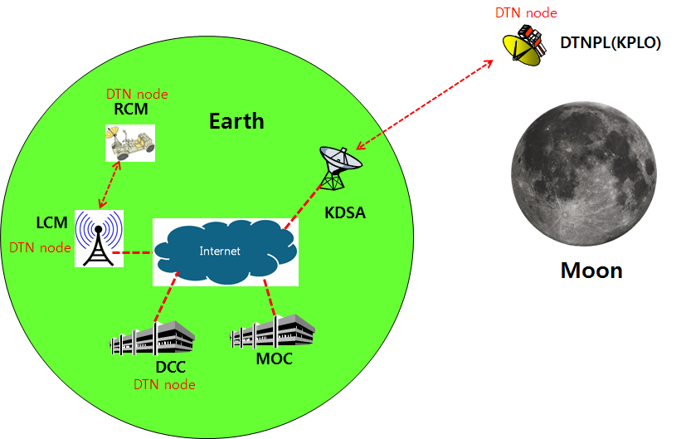
Figure 2.1 DTN test configuration in the first phase

Communication Nodes
Many communication nodes are needed for the DTN operation. Some of communication nodes in the network are DTN nodes whereas otherwise nodes are non-DTN nodes. The function of communication nodes used in the DTN operation is as follows.

DTN nodes
- DCC is a ground DTN node which monitor and controls DTN nodes. DCC send commands to DTN nodes such as DTNPL, LCM and RCM. It also receives telemetries or acquired data from some DTN nodes such as RCM or LCM.
- DTNPL is a DTN node mounted on the KPLO. DTNPL can be operated as a DTN end point. And it also can be operated as relay nodes which relay DTN data between DCC and RCM or LCM.
- LCM is a ground DTN node. LCM relays DTN data between MOC and RCM.
- RCM is a ground DTN node and a DTN end point. The commands sent by the DCC is terminated at the RCM and the RCM returns telemetry or data to DCC through KPLO.

Non-DTN nodes
- MOC is a non-DTN node. MOC monitors and controls KPLO and payloads. MOC also receives and processes data generated from the payloads and transfers to each payload control center.
- KDSA is a ground station for deep space communication. KDSA will have a big size of antenna and RF equipment for space link interface. KDSA also has network equipment for terrestrial communication interface such as SLE link. KDSA is a non-DTN node.

EGSE Requirement Specification

Functional Requirement

MMI
The DTNPL shall provide Man Machine Interface(MMI).

DTN Protocol
The DTNPL EGSE shall support DTN Protocol.

TC Test Mode
The DTNPL EGSE shall provide TC Test Modes which follows DTNPL ICD.

TM Test Mode
The DTNPL EGSE shall receive telemetry from DTNPL and display readable information through MMI

Logging
The DTNPL shall be capable of save logging data which can be raw data.

De-logging
The DTNPL shall be capable of load saved logging data for troubleshooting.

Performance Requirements

Data Interface Speed
The DTNPL EGSE shall have enough speed of data interface for the communication with DTNPL.

Memory
The DTNPL EGSE shall have enough memory to perform its functions.

Interface Requirements

DC Power Interface
The DTNPL shall provide DC power to DTNPL.

Operating Voltage
The DTNPL shall be capable of providing the voltage range 24VDC ~ 32VDC.

Data Interface
The DTNPL EGSE shall have serial data bus interface for the communication with DTNPL.

Data Interface Format
The DTNPL EGSE transaction data shall be compatible with CCSDS DTN standards and RFC specifications.
.

Verification Matrix
The verification matrix is shown below.

SRS ID | Title | Methods
SRS ID | Title | T | A | I | D | S
3.1.1 | MMI |  |  |  | O
3.1.2 | DTN Protocol | O
3.1.3 | TC Test Mode | O
3.1.4 | TM Test Mode | O
3.1.5 | Logging | O
3.1.6 | De-logging | O
3.2.1 | Data Interface Speed |  |  |  | O
3.2.2 | Memory |  |  |  | O
3.3.1 | DC Power Interface |  |  |  | O
3.3.2 | Operating Voltage |  |  |  | O
3.3.3 | Data Interface | O
3.3.4 | Data Interface Format | O

